Name: Gunnar Forcier Oral/Interpersonal Communication

Chapter 8 Activity A: Culture and Identity (5 Points)

This activity expands on the concepts of perception and self-concept that we studied in Chapter 2.

Section 8.1 defines culture and highlights aspects of our identities: “Culture is an ongoing negotiation of learned patterns of beliefs, attitudes, values, and behaviors.” It is dynamic, not static. In addition, each of us has personal, social, and cultural identities.

1. Review the culture wheel below. You should be able to correlate the wheel’s dimensions of diversity with concepts addressed in Sections 8.1 and 8.2.

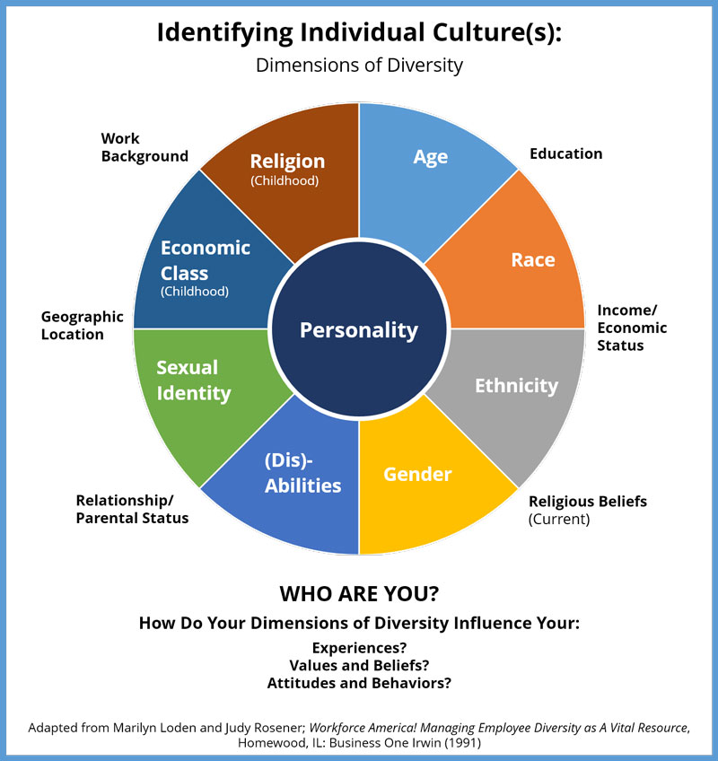

2. Next, designate four of the cultures inside or outside of the culture wheel that you most identify with. (Which ones are most salient for you?) To help you arrive at your choices, you might answer the following questions:

* What do you most identify with?
* What do you spend the most time thinking about?
* What do you spend the most time in or doing?
* What do you value, or think is most important?

My list of the four cultures I chose:

A. Age

B. Gender

C. Work Background

D. Economic Class

3. Based on what you’ve determined as those four most salient cultures, answer the following question in a little bit of detail: What would a person who looked at this list be able to perceive about you?

* I think they might be able to get a hint of my upbringing. I think the fact that age is at the top would probably lead them to think I’m either young or old, as that’s all people might see about you at those ages. Gender is a toss up I think, but I think being a male and growing up encouraged to do all the stereotypical male hobbies like sports and video games was a big part of my life. You might be able to infer that I’ve had a wide variety of jobs. They might also take note of the cultures not present like race and ethnicity to infer that I’m white and haven’t really had my race impact my life in a significant way.